**Creating table in hive using complex data types**

create table customers1(id int,name string,email_preferences struct<email_format:string,frequency:string,categories:struct<promos:boolean,surveys:boolean>>,addresses map<string,struct<street_1:string,street_2:string,city:string,state:string,zip_code:string>>,orders array<struct<order_id:string,order_date:string,items:array<struct<product_id:int,sku:string,name:string,price:double,qty:int>>>>);

desc customers1;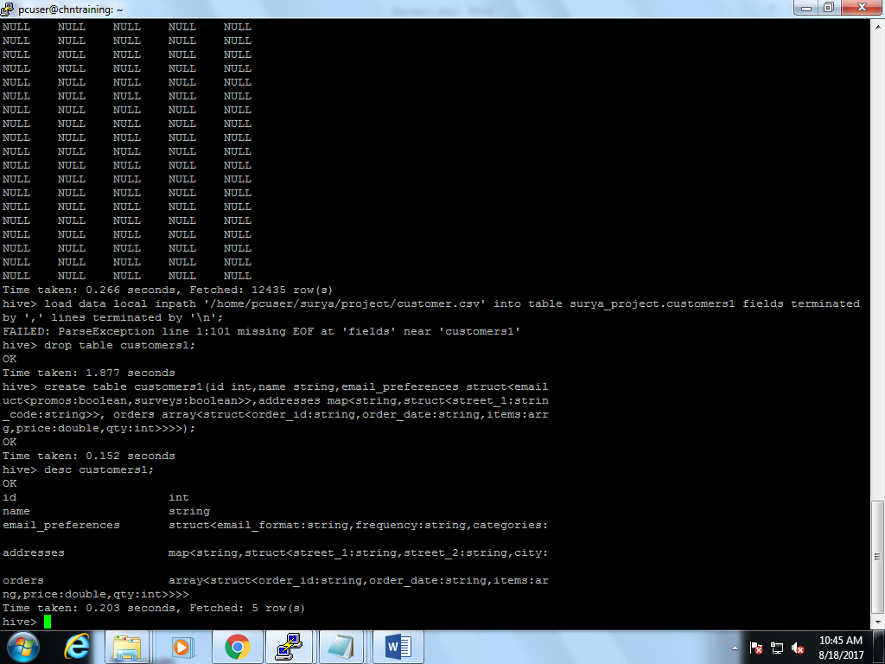

**//** Hive table with complex data type is created.

**Day 2**

**1. Create a denormalized hbase table for retail:**

create table hnew as

(select c.customer_id,c.customer_fname,c.customer_lname,c.customer_email,c.customer_password,c.customer_street,c.customer_city,c.customer_state,c.customer_zipcode,o.order_date,o.order_id,o.order_status,oi.order_item_quantity,oi.order_item_id,oi.order_item_subtotal,oi.order_item_product_price,p.product_id,p.product_name,p.product_price,p.product_image,p.product_description,ca.category_id,ca.category_name,d.department_id,d.department_name from orders o, products p, order_items oi,customers c,departments d,category ca where (o.order_id=oi.order_item_order_id) and (oi.order_item_product_id=p.product_id) and (c.customer_id=o.order_customer_id) and (p.product_category_id=ca.category_id) and(ca.category_department_id=d.department_id);

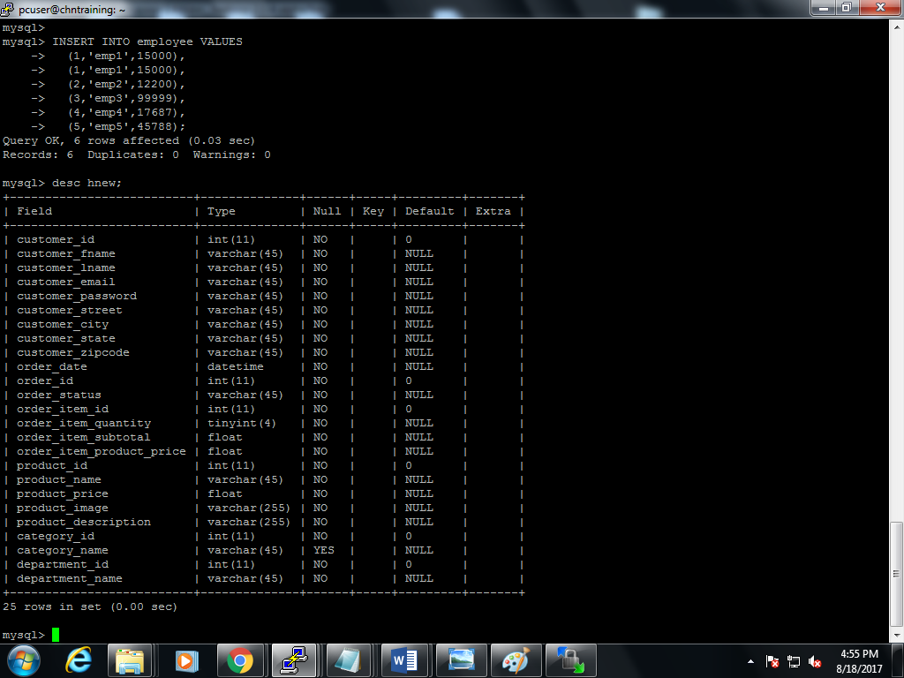

**25 columns.**

**Importing table “hnew” from mysql into hive:-**

Sqoop/bin$:- sqoop import –connect jdbc:mysql://localhost/surya_project –username root –password root –table hnew –hive-import –hive-table surya_project.hnew –m 1;

Hdfs :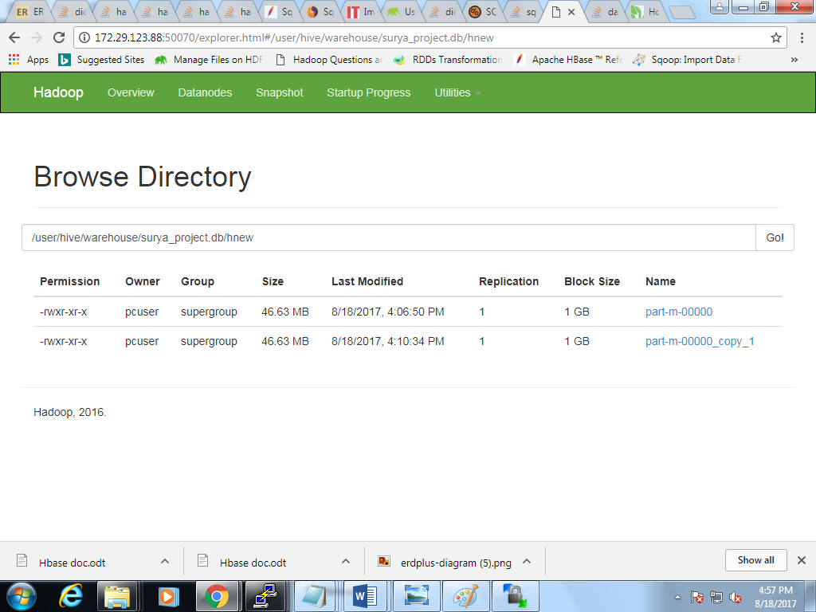

**creating a table in hive for hbase**

create table htable(customer_id int,customer_fname string,customer_lname string,customer_email string,customer_password string,customer_street string,customer_city string, customer_state string, customer_zipcode string,category_id int,category_name string,order_id int,order_date string,order_status string,order_item_id int,order_item_quantity int,order_item_product_price int,order_item_subtotal float,department_id int,department_name string,product_id int,product_name string,product_description string,product_price float,product_image string) stored by 'org.apache.hadoop.hive.hbase.HBaseStorageHandler' with serdeproperties ("hbase.columns.mapping" = ":key,c1:customer_fname,c1:customer_lname,c1:customer_email,c1:customer_password, c1:customer_street,c1:customer_city,c1:customer_state,c1:customer_zipcode,c1:category_id,c1:category_name,c1:order_id,c1:order_date,c1:order_status,c1:order_item_id,c1:order_item_quantity,c1:order_item_product_price,c1:order_item_subtotal,c1:department_id,c1:department_name,c1:product_id,c1:product_name,c1:product_description,c1:product_price,c1:product_image") TBLPROPERTIES ("hbase.table.name" = "htable_surya");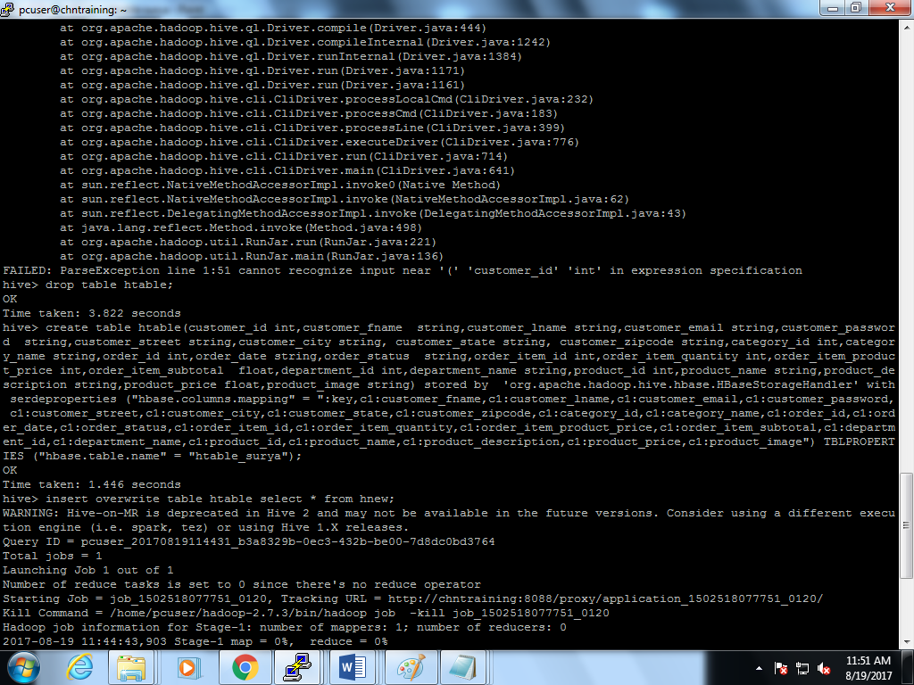

**Integrate hive table with hbase table**

//overwrite into the htable in hive by already using the denormalised table in hive.

insert overwrite table htable select * from hnew;



**Output in hbase:**

Scan from ‘htable_surya’

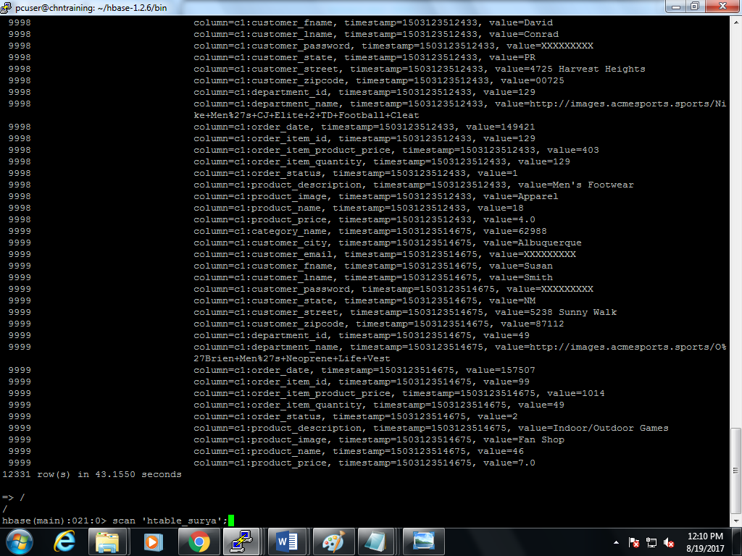

The table shown in hdfs 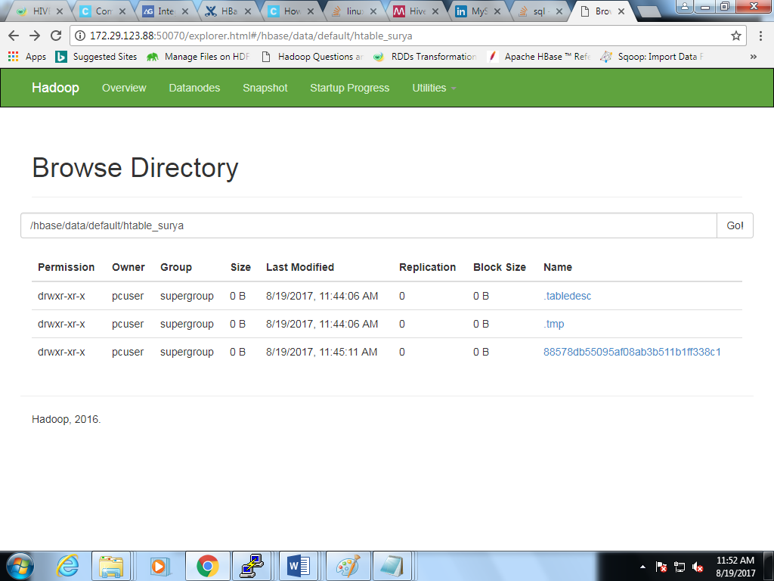

**Mapping of hive and hbase columns Output as seen in hive:**

**Output as seen in hive:**

Desc htable;

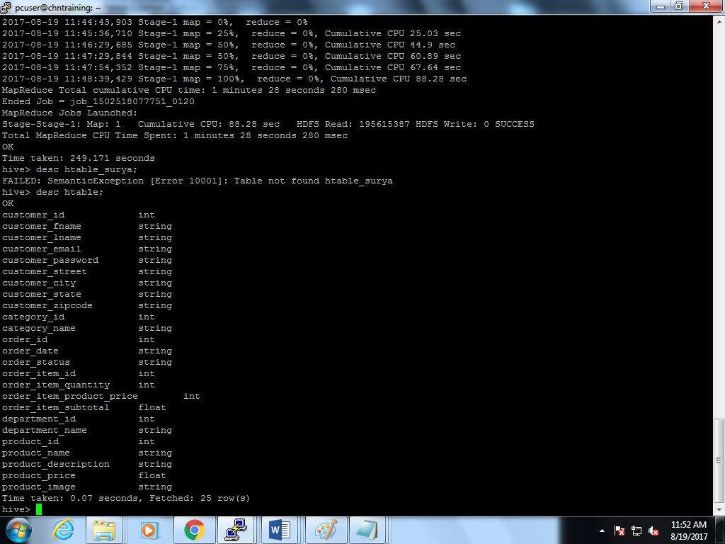

Select * from htable;

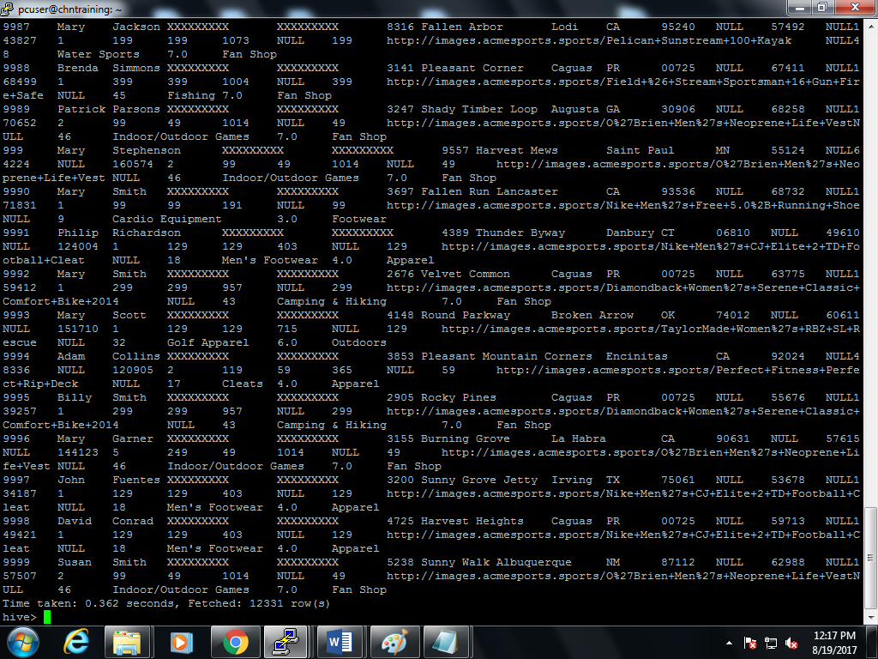

**Output as seen in HBASE:**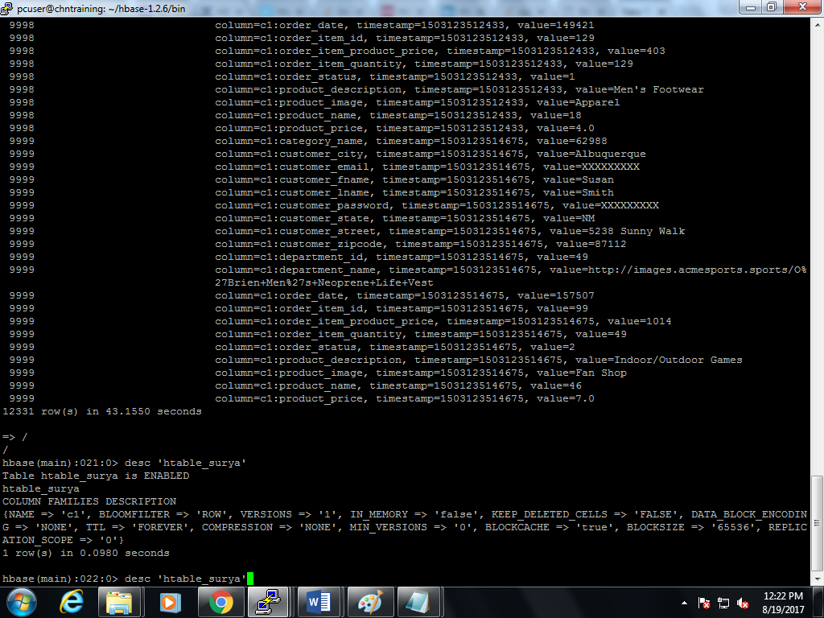

Scan 'htable_surya'



**DML operations**

1) Select * from products order by product_price desc limit 5;

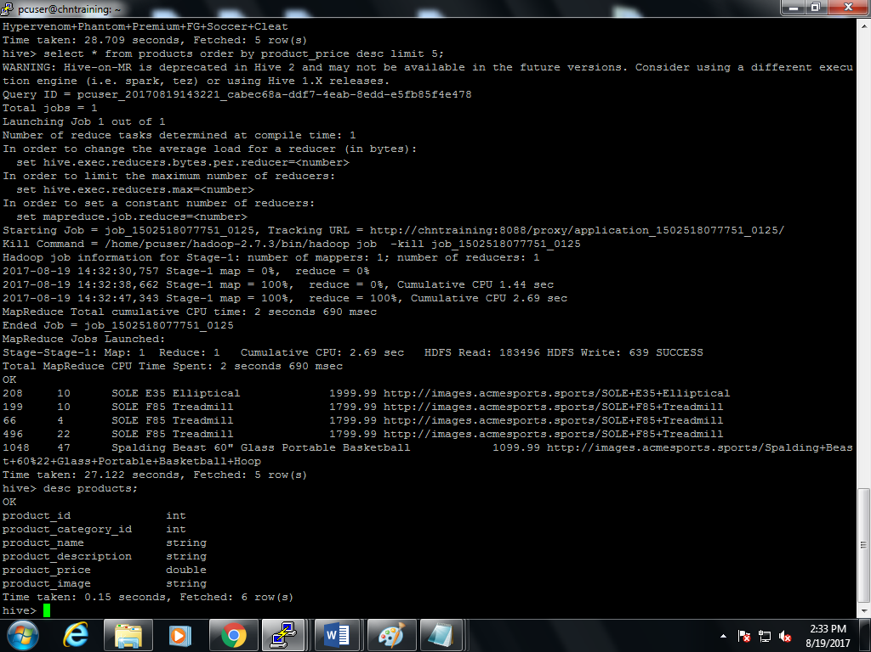

//transferring products table from hive to hbase to perform update/delete operations:

//In hive update/delete operations can be achieved by setting ACID property setting transactions=true or from ambari.

**Creating table in hbase from hive:**

create table hproducts(product_id int,product_category_id int,product_name string,product_description string,product_price double,product_image string) stored by 'org.apache.hadoop.hive.hbase.HBaseStorageHandler' with serdeproperties ("hbase.columns.mapping" = ":key,p1.product_category_id,p1.product_name,p1.product_description,p1.product_price,p1.product_image") TBLPROPERTIES ("hbase.table.name" = "htable_surya_products");

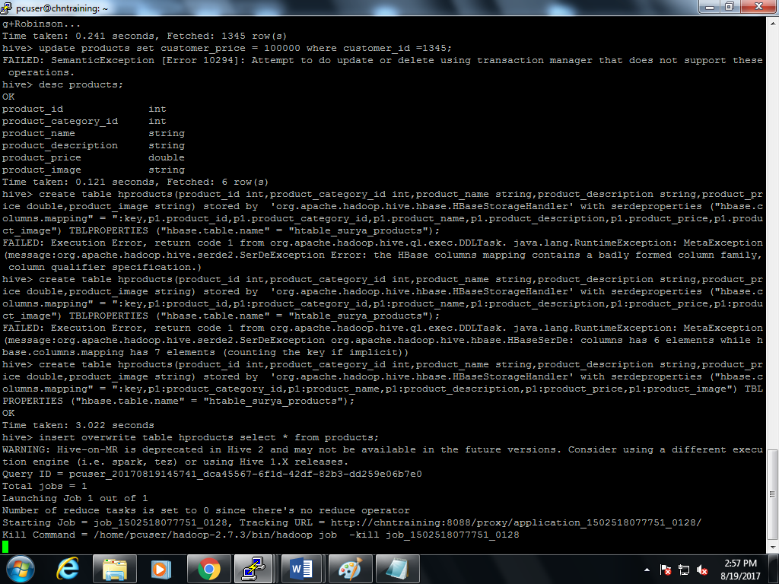

insert overwrite table hproducts select * from products;

**hbase products table output:**

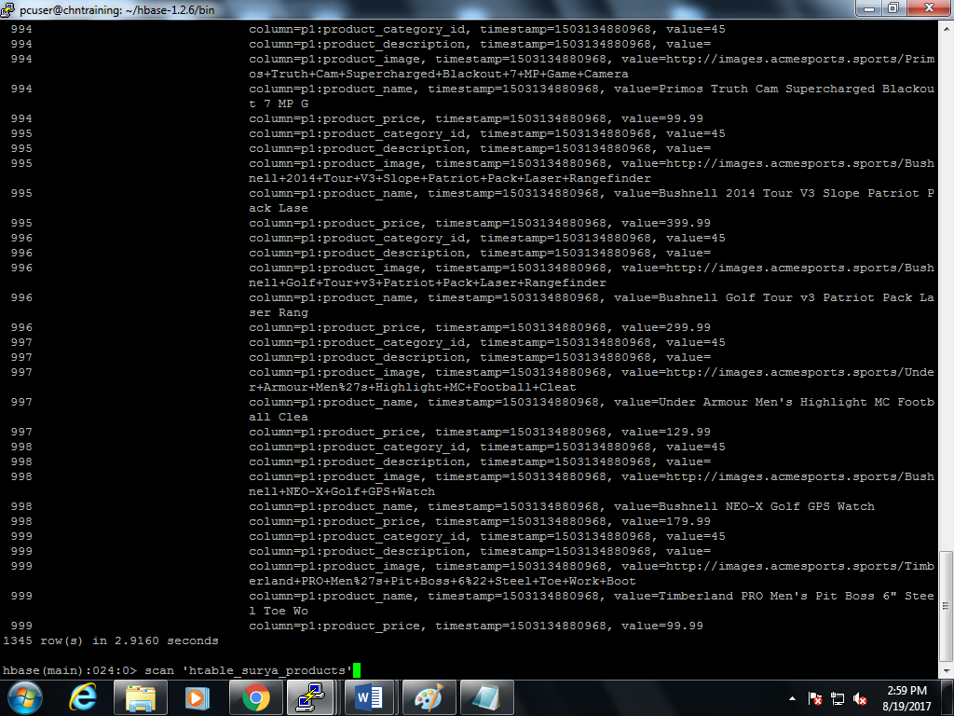

**Select operations**

hbase>get 'htable_surya_products','999'

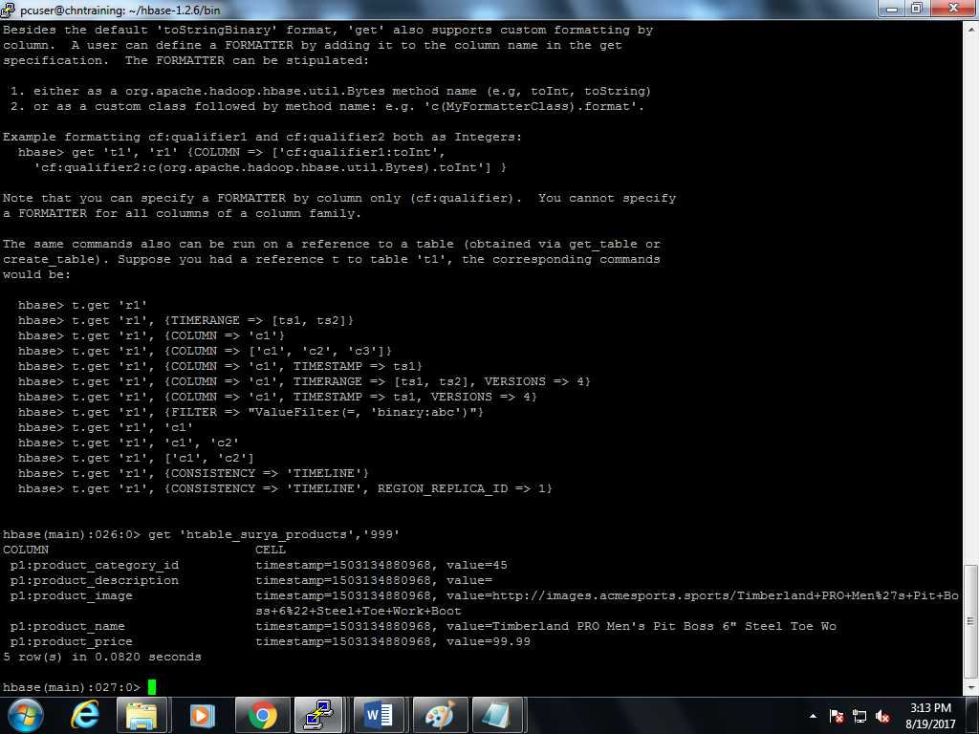

**Insert operations**

hbase>put 'htable_surya_products','007','p1:name','james bond'

hbase>get 'htable_surya_products','007'

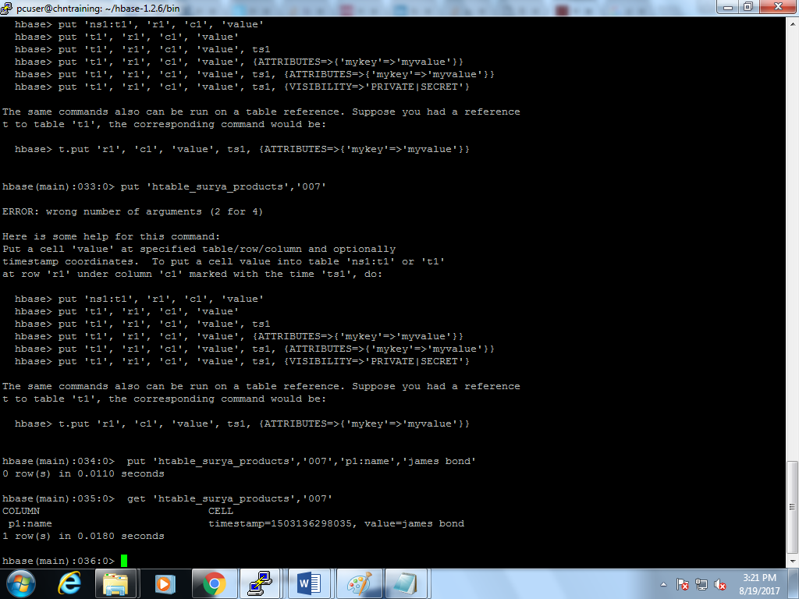

hbase>put 'htable_surya_products','007','p1:price','1212'

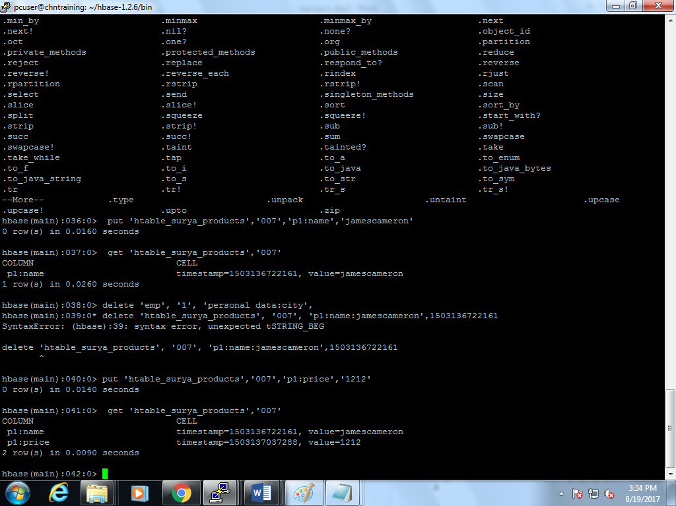

**Updating**

hbase>put 'htable_surya_products','007','p1:name','james cameron’

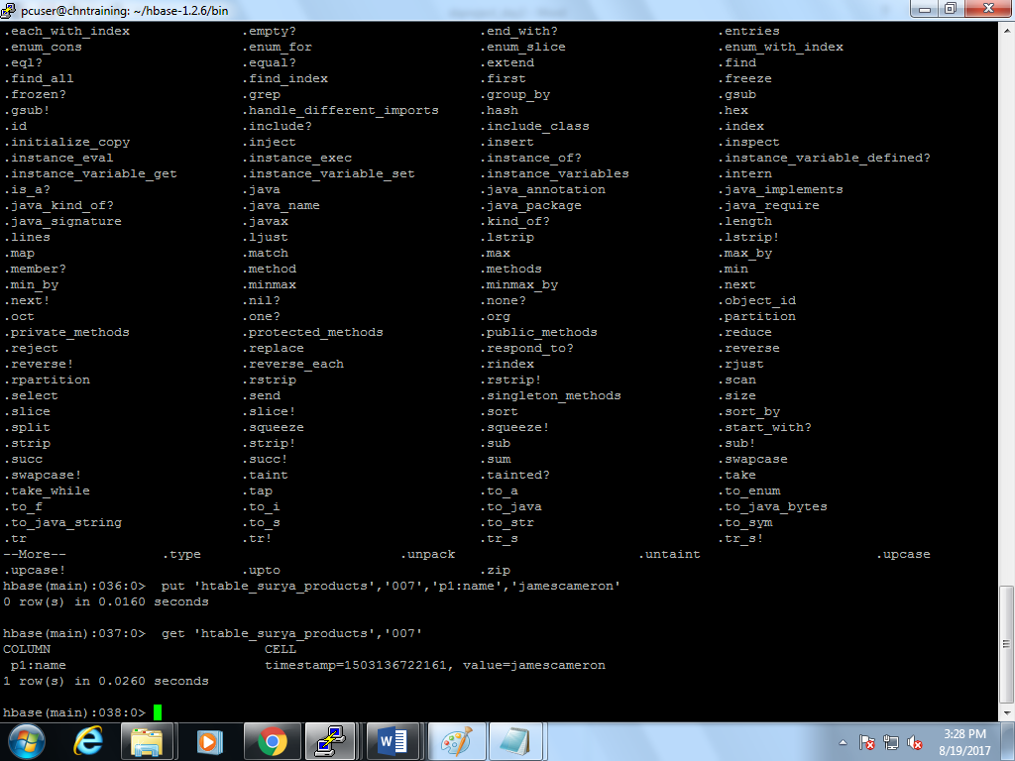

**Deleting**

hbase>Delete'htable_surya_products','007','p1:name:jamescameron','1503136722161'

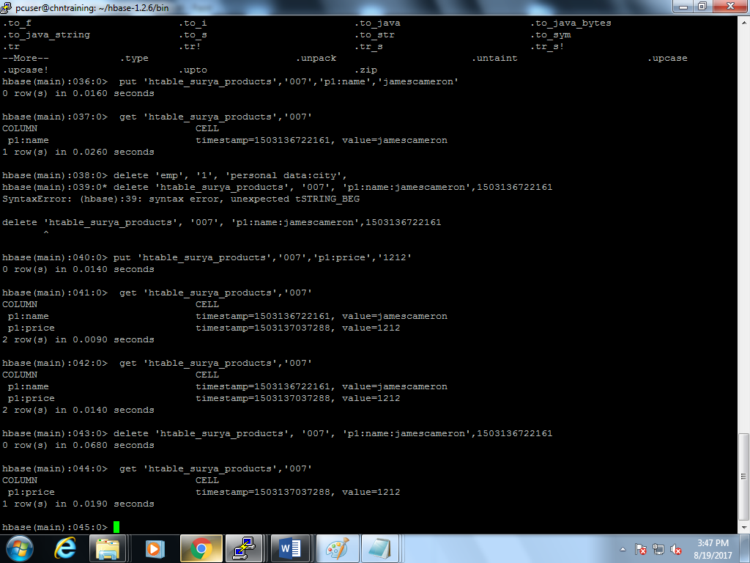

**Access the hive data in spark-sql:**

In hive my database name is surya_project;

In spark bin:-./spark-sql

show databases;

use surya_project;

select customer_id,product_id from hnew;

